UB Child Protection Policy Training Course Instructions
Follow the instructions below to complete the online training course via UB Learns
UB Learns Website Link: https://ublearns.buffalo.edu/
*Important note: This course will not work when using the Internet Explorer (IE) internet browser.
Verify that your internet browser is compatible. To use UB Learns, use a computer that is connected to the Internet and the most up-to-date web browser. It is recommended that you use the most current version of:
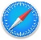



Chrome Safari
Firefox Microsoft Edge
Brightspace technical support offers a list of certified and compatible browsers, listed by Operating System, for use with UB Learns D2L Brightspace Compatible Browsers (UB Learns).
Accessing the Course
- Go to UB Learns and select “Go To Brightspace”.
  - Enter your UBIT Name and Password Click Login.
To look up your UBIT Name please go to: https://www.buffalo.edu/search/you
- You may be prompted to verify your identity via UB DUO.

Discovering the Course
If you do not see the UB Child Protection Policy Training you will need to:
- Discover the course
- Self-Enroll in the course
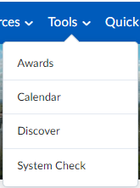
- From the UB Learns homepage, select Tools
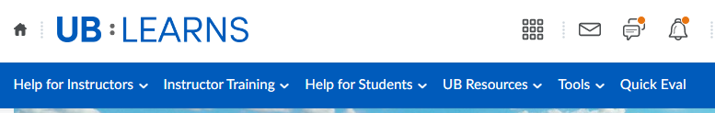
- Select Discover
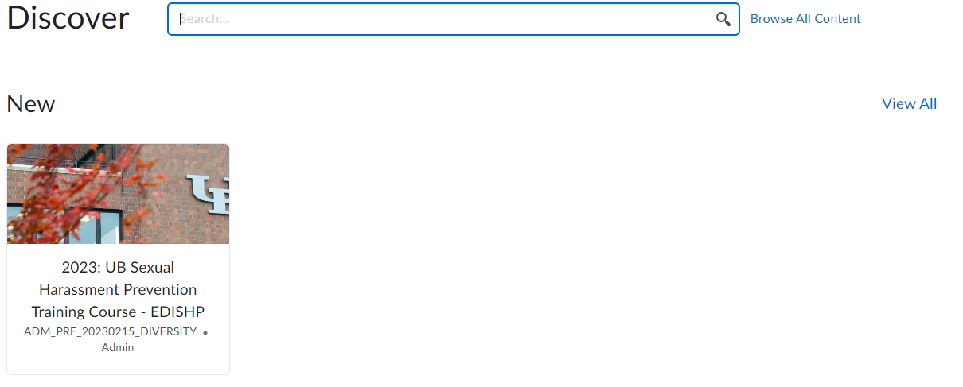
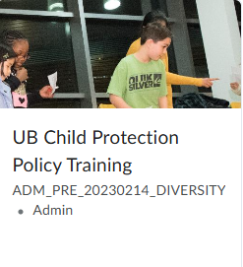
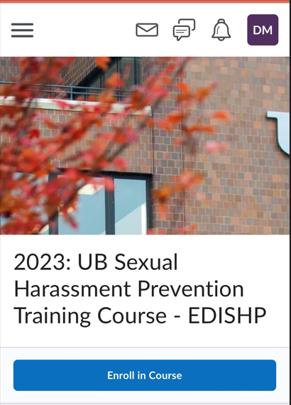
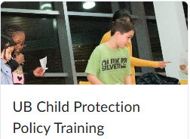
- Select UB Child Protection Policy Training Course:
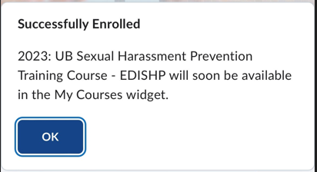
- Select Enroll in Course
UB Child Protection Policy Training Course – will soon be available in the My Courses widget.
- Select OK for Successful Enrollment:
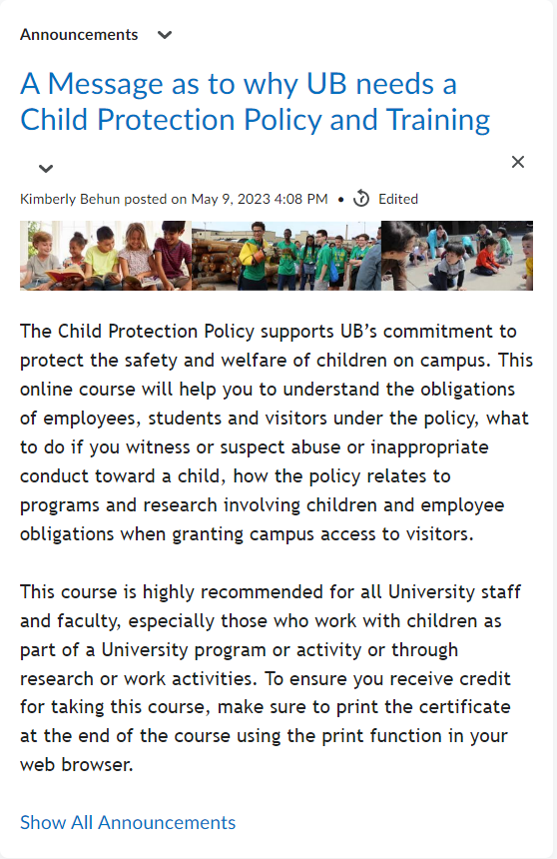
- Read the message from UB.
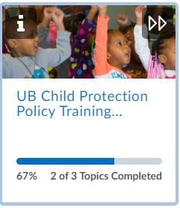
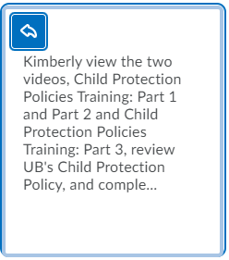
- The Visual Table of Contents Widgets guides you through the course and additional resources available to you outside of the course content. For additional information regarding each Widget:
Select the i on each widget to ‘flip’ the Widget and gain details on the Widget.
The additional Information for each Widget will display:
To flip back to the original view:
Select the Back Arrow in the upper left corner of the tile.

- Select the UB Child Protection Policy Training Course
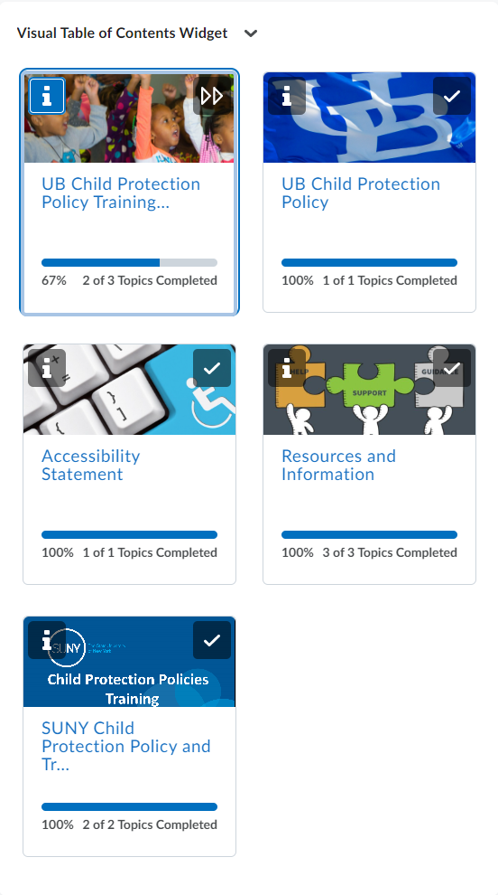
The course requires you to watch the videos, complete a short quiz, and review the UB Child Protection Policy. If need you may need to visit the SUNY Child Protection Policy and Training Widget.

- Select Watch the UB Child Protection Policy Training Course Videos.
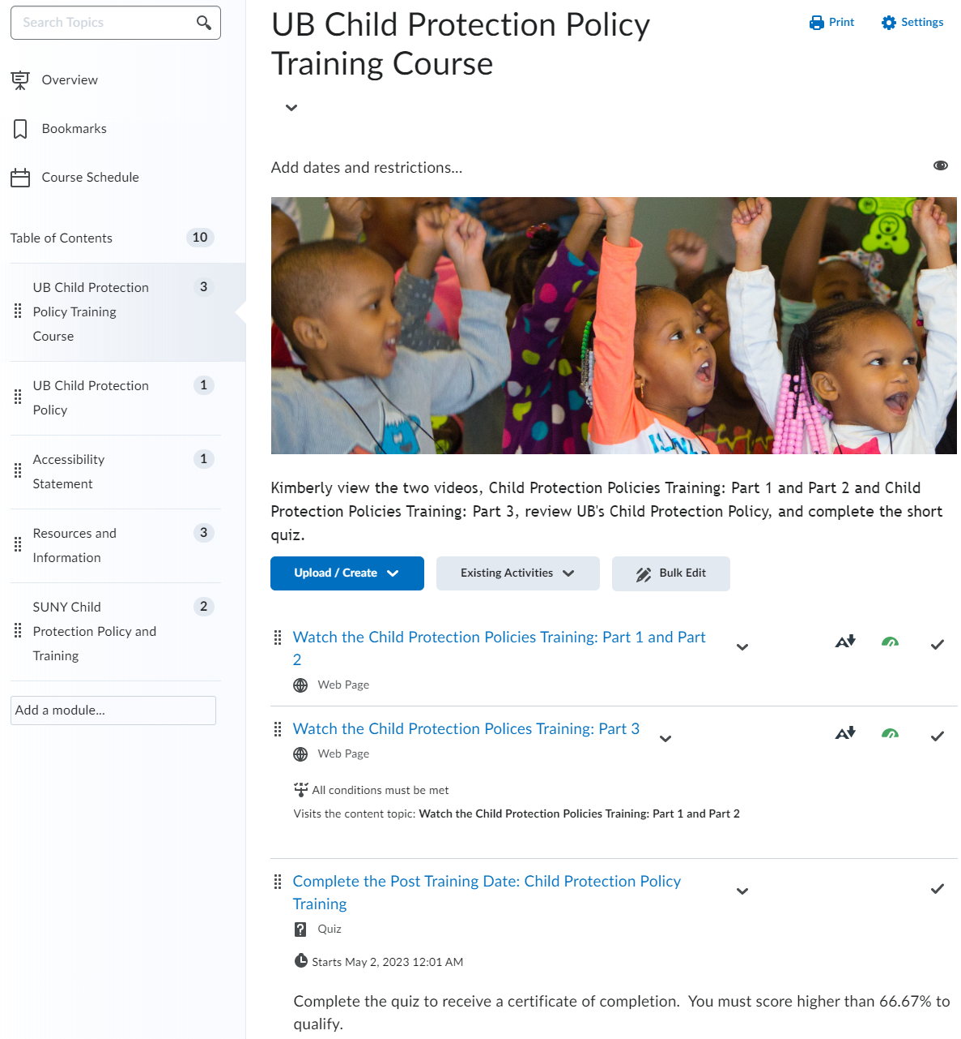
Video Part 1 and 2
Quiz: link will appear after watching the video
Video Part 3

- Play the UB Child Protection Policies Training: Part 1 and Part 2
Start the training by selecting the play button in the middle of the screen.
You may choose to watch the video by downloading the video, opening the video in a new window or by making the video full sized.
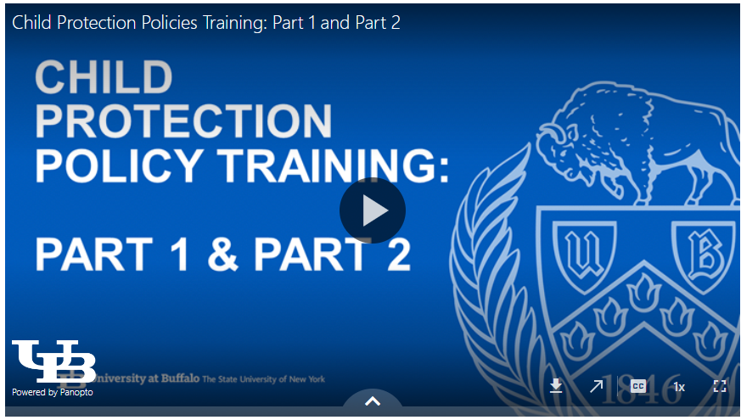
Panopto is the video platform that was used to create the training video. The software requires your internet browser to accept third-party cookies. The Safari internet browser in particular may require you to change your settings in order to view this type of video file.
If you are using an Apple device (i.e. MacBook, iMac, iPad or iPhone) and the Safari browser, please review the following information regarding Panopto and the Safari internet browser:
How to enable support for Third Party browsers
Speed of Speaking

Download
Open New
Window
Toggle Captions
Full Sized Video Window
Alternative Formats and Accessibility Features:
To access Alternative Formats
Select the Alternative Formats link below the video.
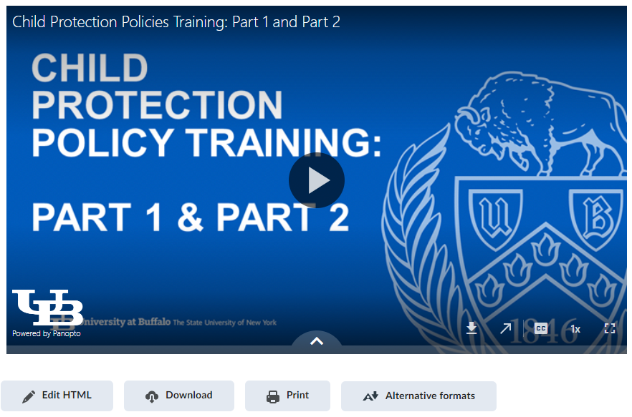
Alternative Formats for the training video
This will bring up the options to select multiple formats to review the training material.
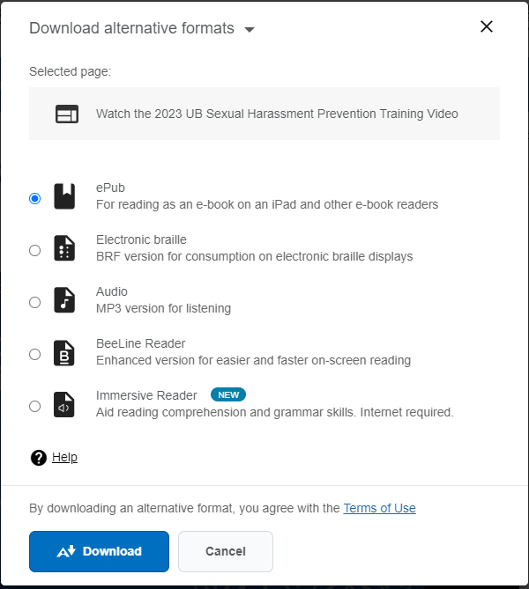
Select the desired format and select Download.
- Post Training Quiz:
  - Navigation Option I:
To begin the Quiz select the right arrow button above the video:
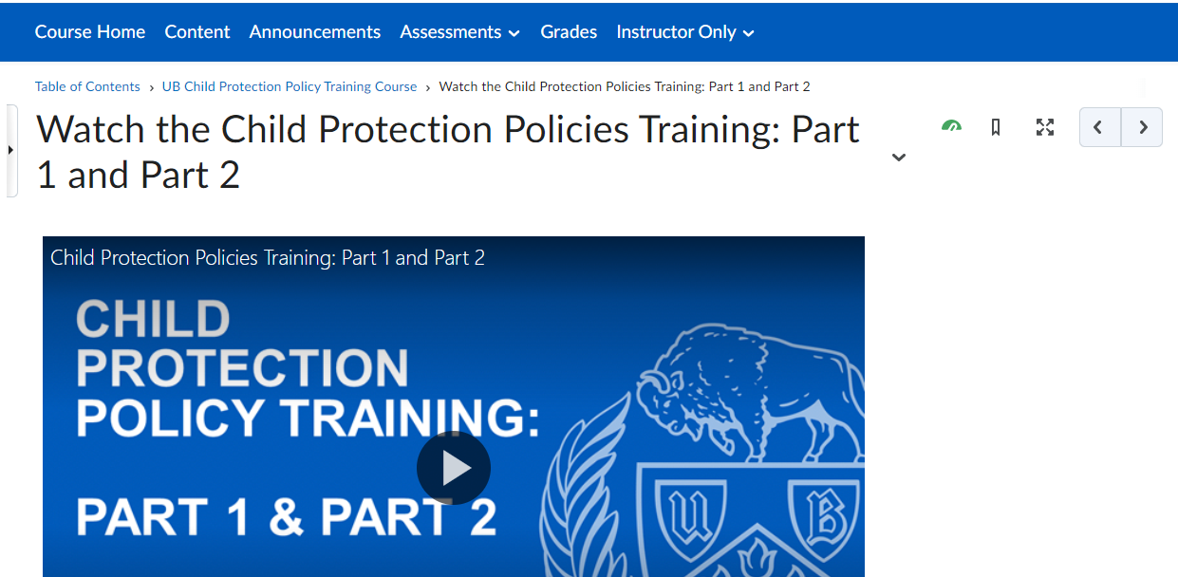
The next page displays:
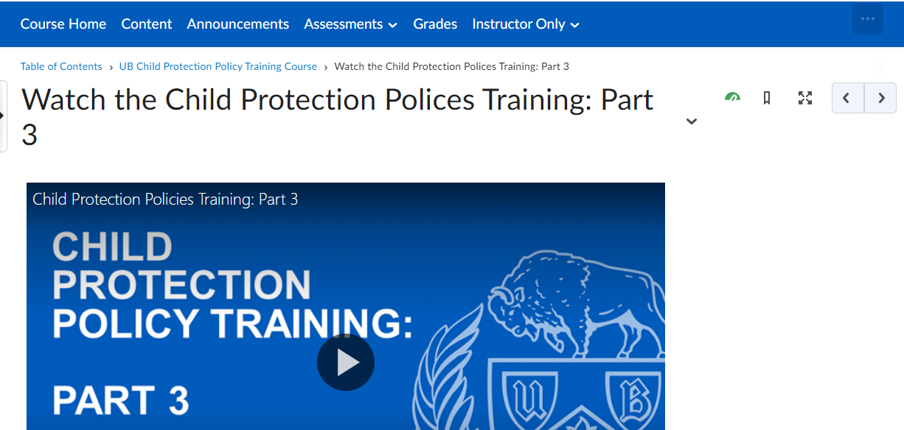
Watch the Child Protection Policy Training: Part 3
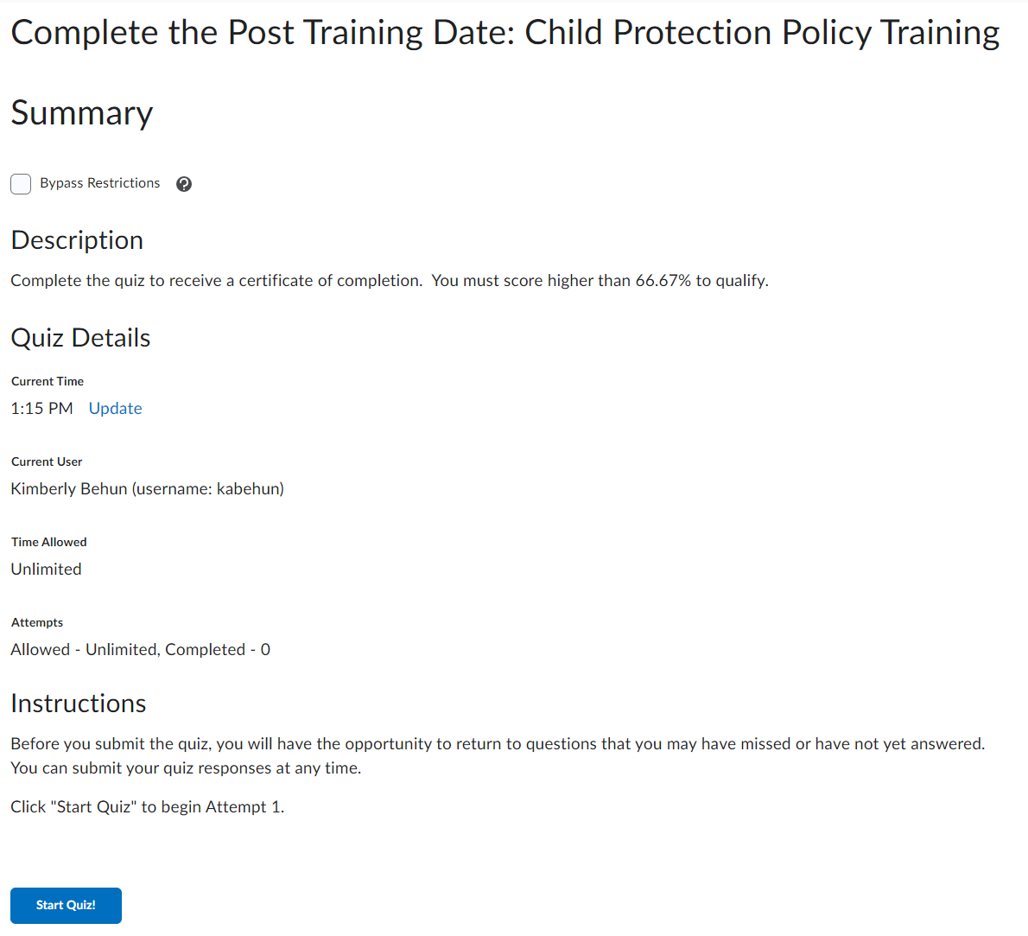
Select Right Arrow
Select Right Arrow
Select Start Quiz!
  - Navigation Option II:
Navigate to the UB Child Protection Policy Training Course.
Select the navigation link UB Child Protection Policy Training Course, the breadcrumb navigation, below the horizontal navigation bar.
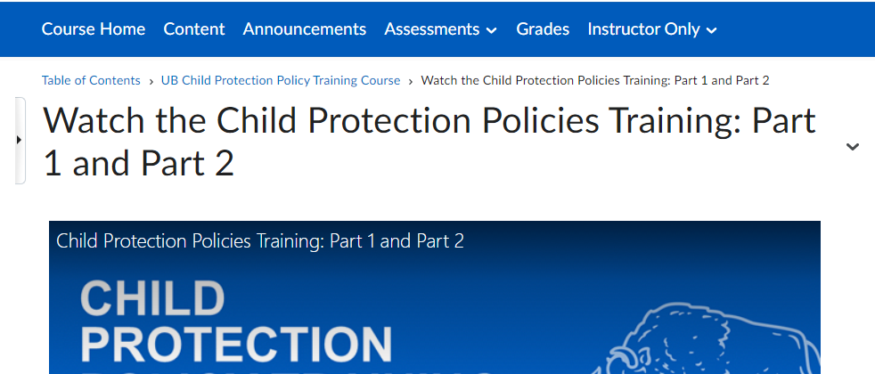
Select Watch the Child Protection Polices Training: Part 3
Breadcrumb Link

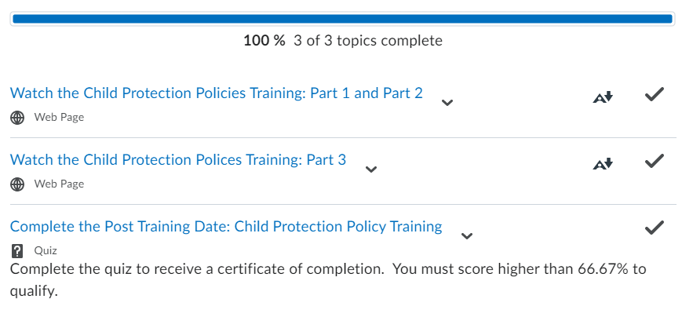
  - 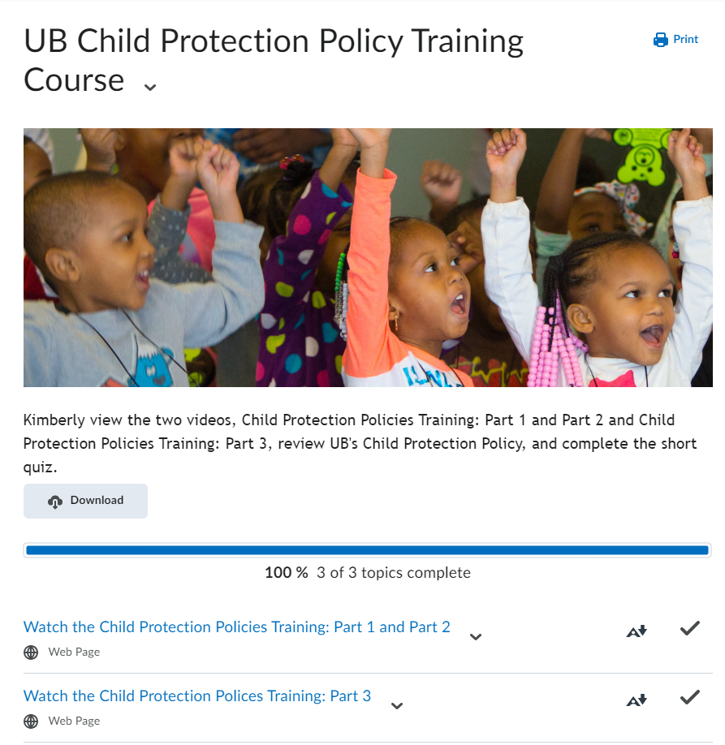
Navigate to the quiz via the upper right arrow or by following the breadcrumbs.
Once both videos have completed your link for the quiz will appear in the UB Child Protection Policy Training Course module.
Select the Complete the Post Training Quiz: Child Protection Policy Training link
Select Part 3 Link
Select link to begin quiz.
- Complete the Quiz
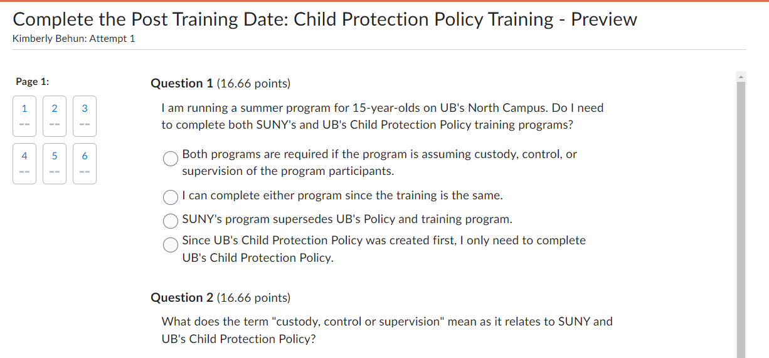
Status of Quiz Completion
  - Once you answer all the quiz questions select Submit Quiz, and select Submit Quiz a second time and the following page will appear:
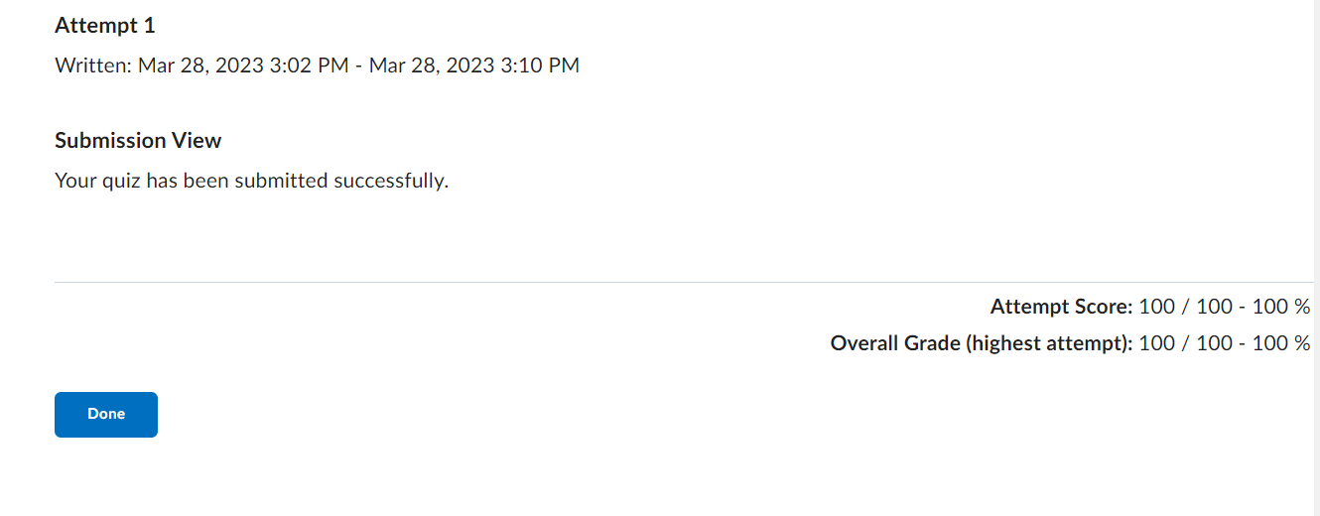
Select Done and you will be taken to the next page
  - You will receive a Post Quiz Summary Page:
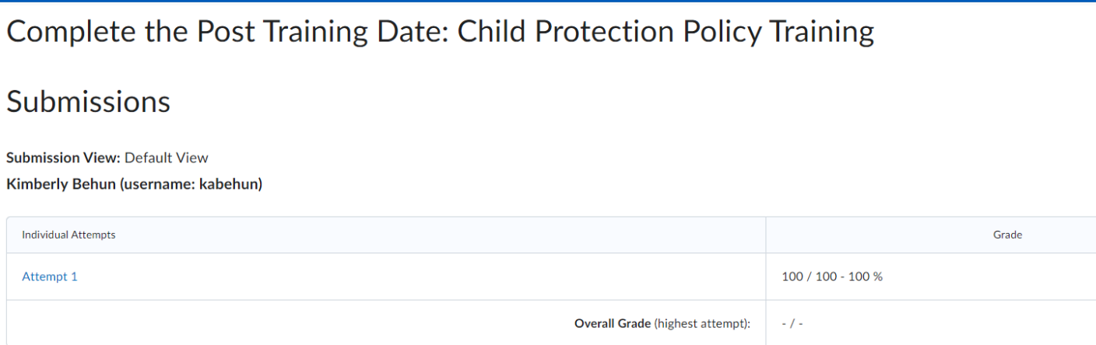
Your Name, (username: your UBIT Name)
  - Select the Right Arrow
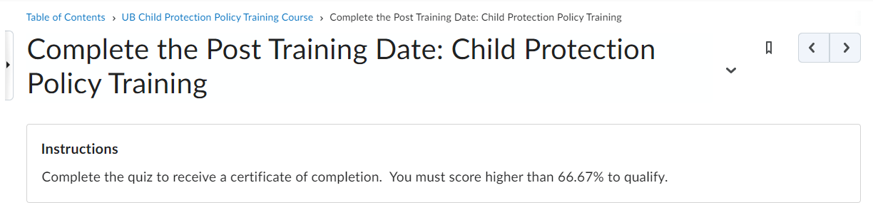
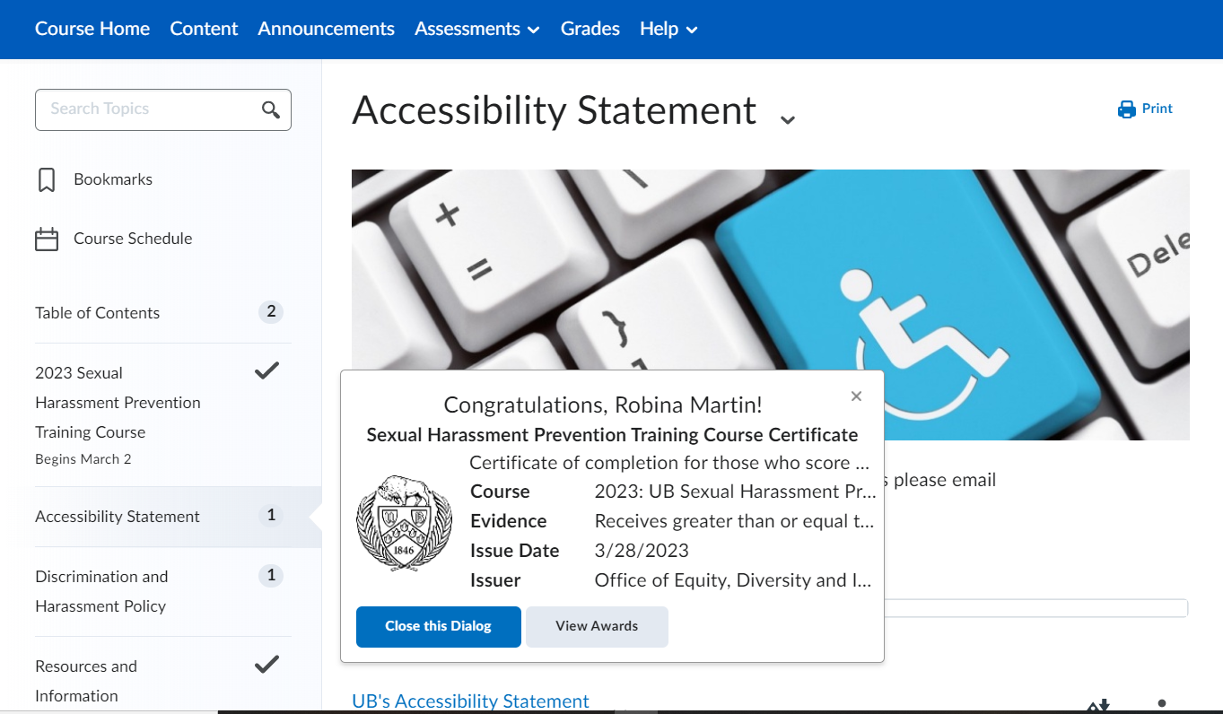
  - You will be taken to the next Table of Contents component and the following pop-up will display if you completed the quiz and the acknowledgements:
Quiz Completion Pop-up
Your Name!
UB Child Protection Policy Training Course
MM/DD/YYY
UB Child Protection Policy Training Course
UB Child Protection Policy Training Course

- Viewing Your Awards/Certificate of Completion
Select View Awards
If you do not receive a pop-up listed above you may access your certificate by the following:
UB Child Protection Policy Training Course
UB Child Protection Policy Training Certificate
MM/DD/YYYY
Select View Awards to create a Certificate!
Your Name!
UB Child Protection Policy Training Course
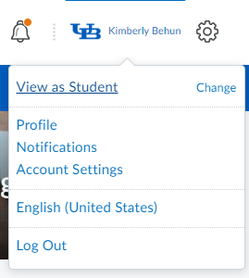
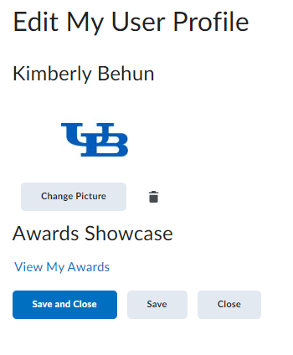
  - Select the Messaging icon to view the latest updates about the course:

  - Select your Profile Name and select Profile:
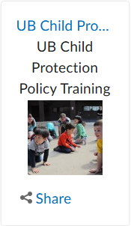
  - Select View My Awards:
  - Select the UB Child Protection link
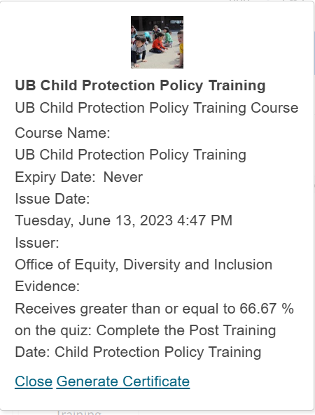
The following pop-up will appear:

Select Generate Certificate to create a PDF Certificate of Completion
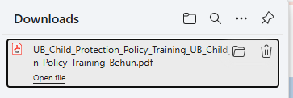
A PDF will Download to your device.

To View the Certificate Open the PDF
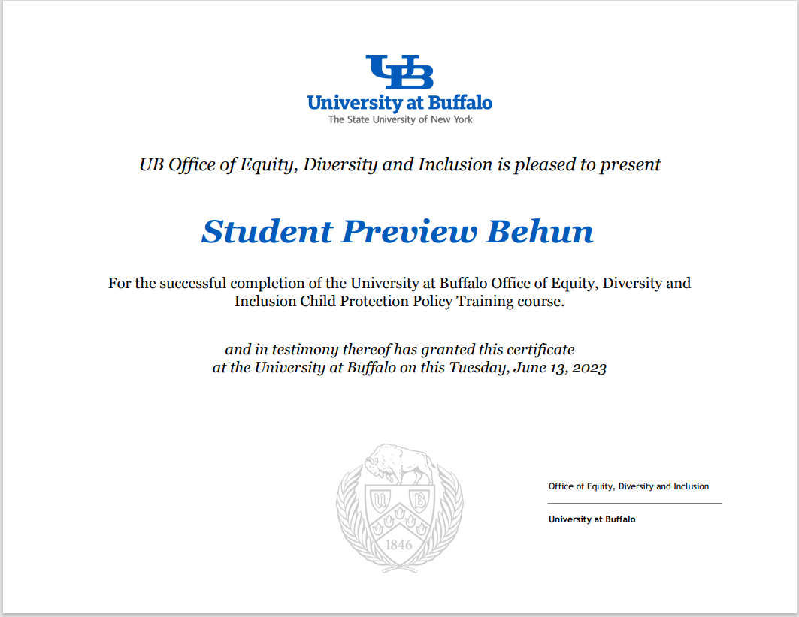
Please DO NOT Email EDI with your certificate. We receive your completion information, and this is entered into our official records. Our training liaisons will have access to our official records.
Your certificate is for external organizations who may require your completion.
Your Name
Day, Month Date, Year
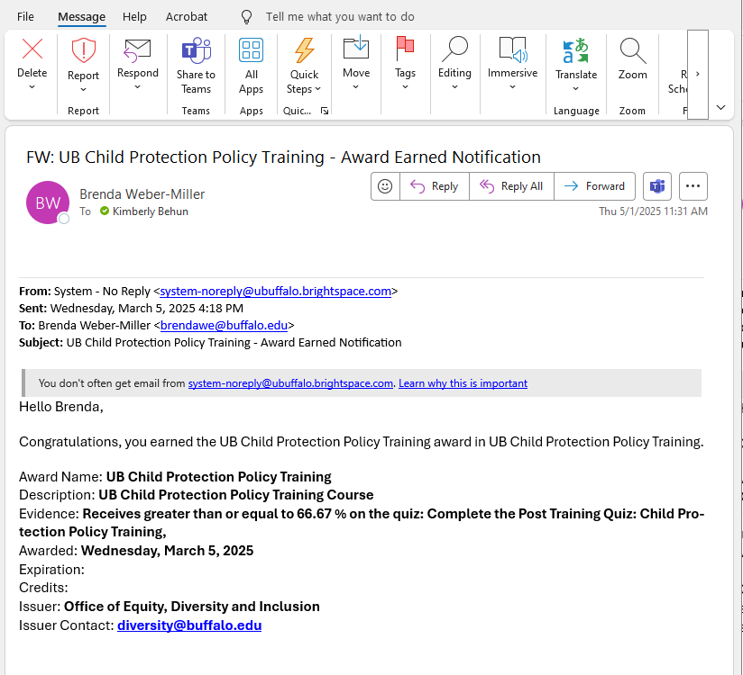
- Course Completion Email
UB Learns Brightspace will email a completion notification to you once you have completed the video and the quiz.
Please DO NOT Email EDI with your Email Notification. We receive your completion information, and this entered into our official records. Our training liaisons will have access to our official records.

Your Name,
- Logout of UB Learns Brightspace
  - Select your name in the upper right corner of your UB Learns window.
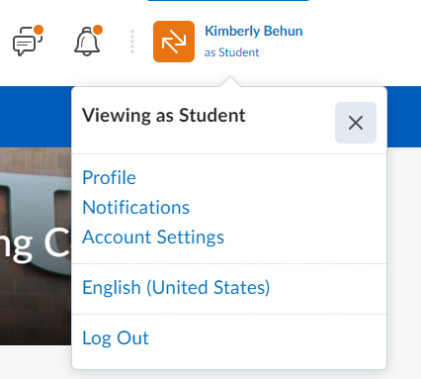
Your Name
  - Select Log Out
  - Close all internet tabs.

For Mobile Phones or Tablets – Accessing UB Learns from your portable device
UB Learns is available within the new Learning Management System via the app named Brightspace Pulse. Brightspace Pulse is available through Google Play® or the Apple App Store®. Requirements for mobile phones or tablets is available on the D2L Brightspace Pulse website.


- Taking the course on a Android Mobile Phone or Tablet:
  - Go to the Google Play™ App on your device
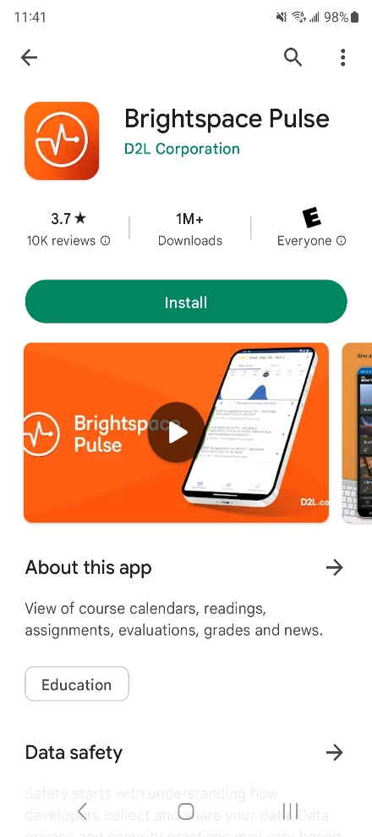
  - Search for the Brightspace Pulse app
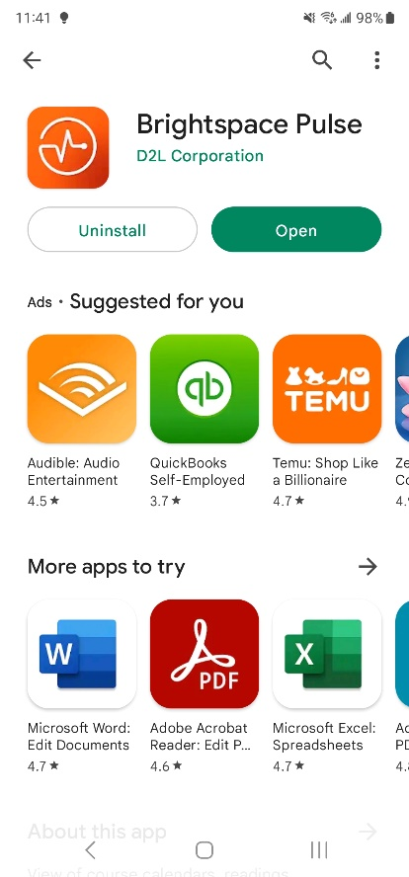
  - Select the Pulse App for Brightspace
and select Install:
  - Brightspace Pulse App will install,
select Open when complete:
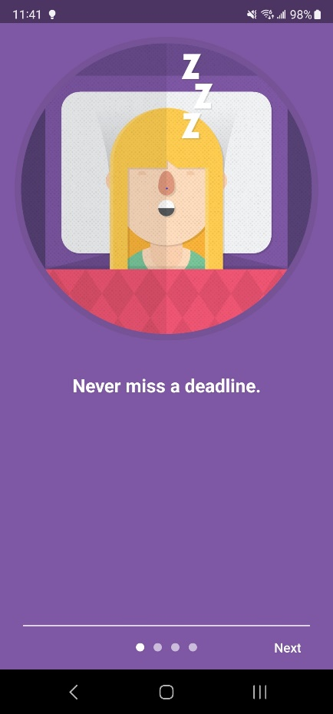
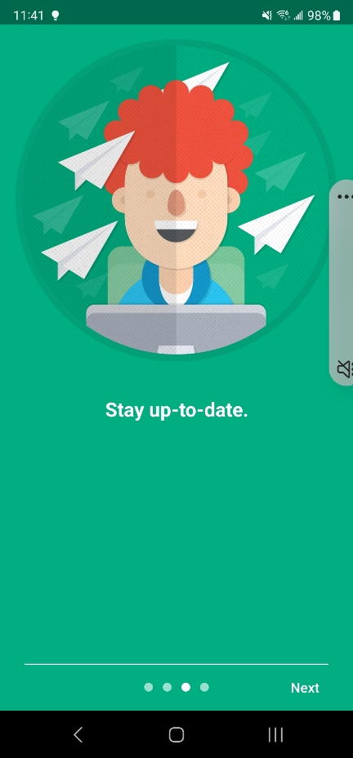
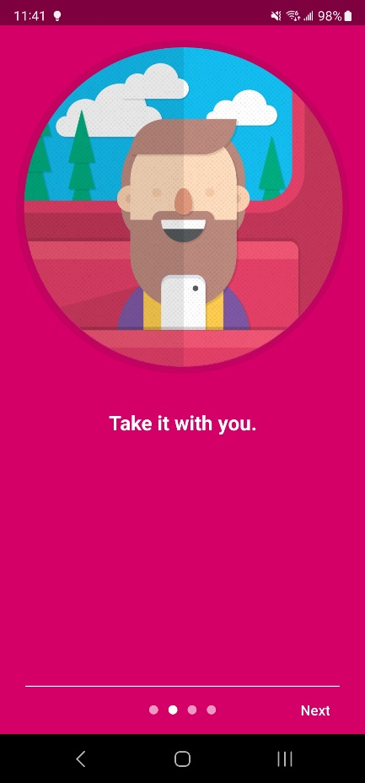
  - There are 3 screens to view the Brightspace APP:
Screen 1
Screen 3
Screen 2
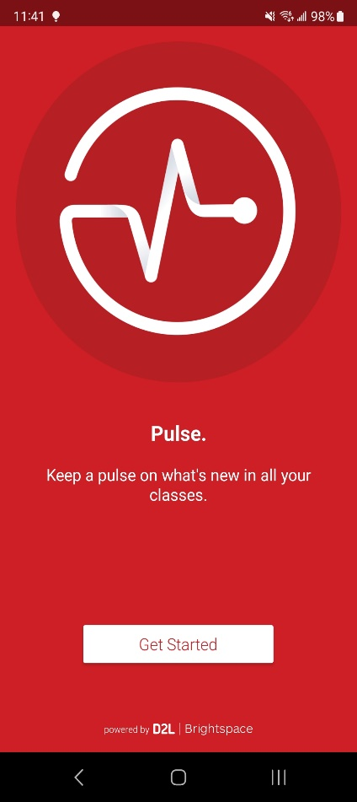
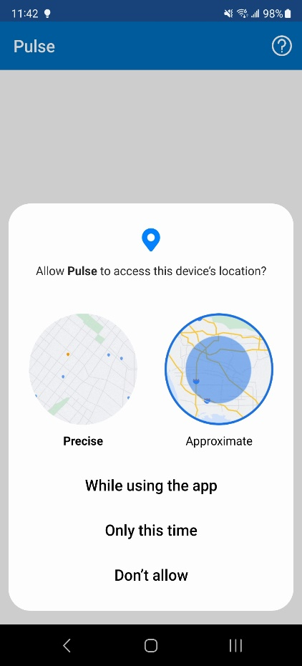

  - On the last screen select Get Started:
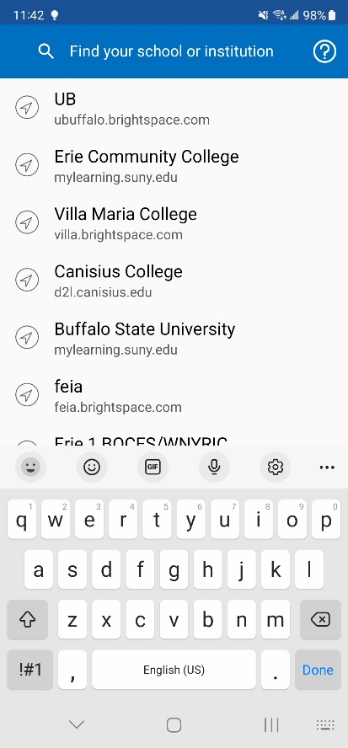
  - Select While using the app
to assist in finding the course:
  - Search for UB:

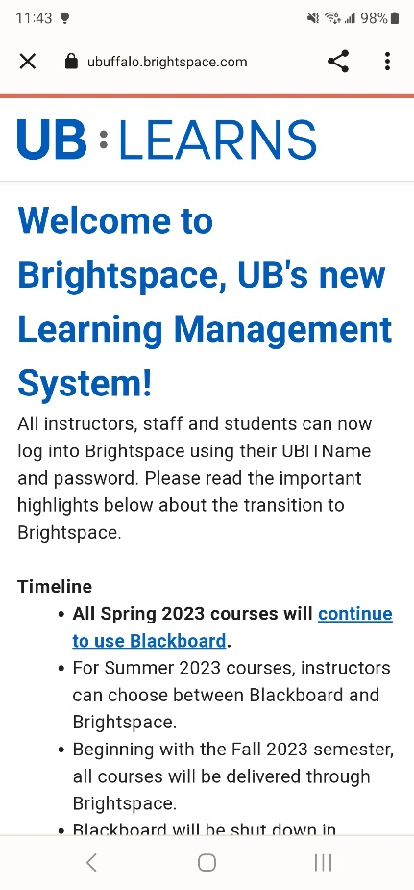
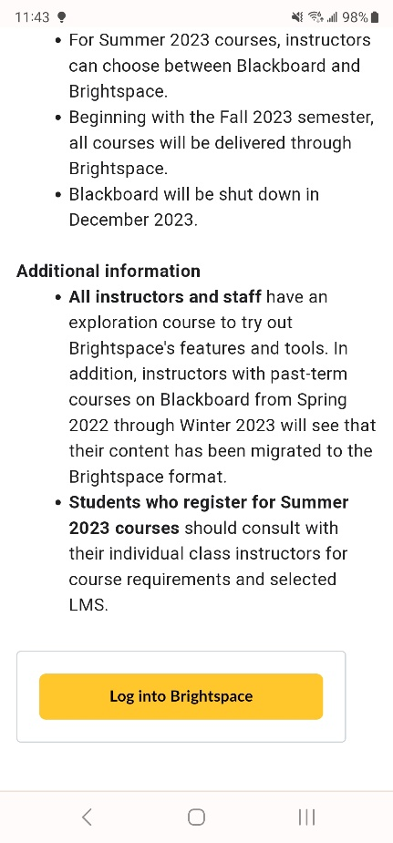
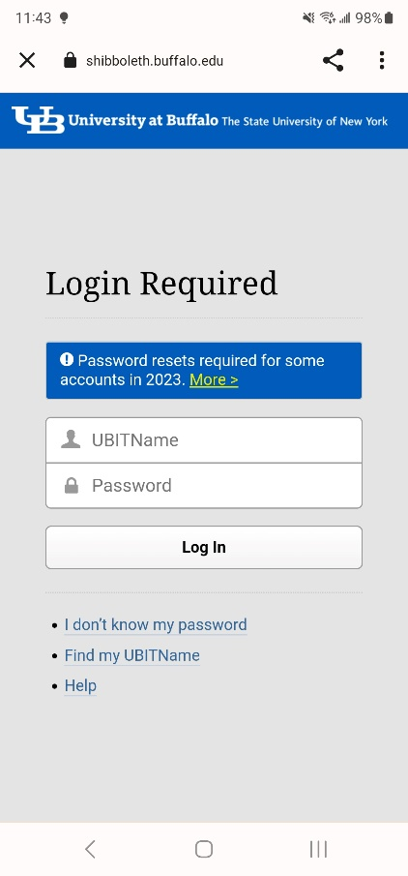
  - Welcome to UB Learns:
Scroll down to Select
Log into Brightspace
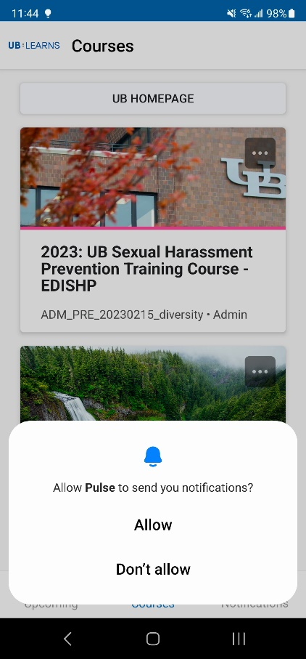
  - Enter your UBIT Name,
Your UBIT Password
Select Log In
You may be prompted for your UB Duo Two-Step Verification
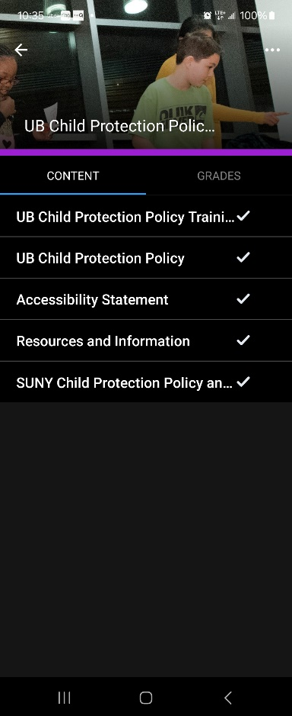
  - Select either Allow or Don’t allow for
Notifications from the Brightspace Pulse App:
This is a personal choice.
  - Begin the course:
    - Select the UB Child Protection
Policy Training Course:
      - Watch the Video
      - Complete the Quiz
    - Select the UB Child Protection
Policy
  - You have completed the course on your Android
device.
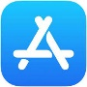
- Taking the course on an iPhone Mobile Phone or iPad:
  - Go to the Apple App Store ® on your device
  - Search for the Brightspace Pulse app
  - Select the Pulse App for Brightspace
and select Install:
  - Brightspace Pulse App will install,
select Open when complete:
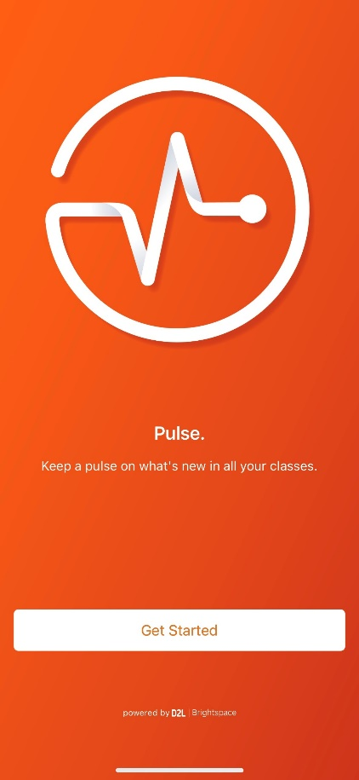
  - There are 3 screens to view the Brightspace APP:
Screen 1
Screen 3
Screen 2
  - On the last screen select Get Started:
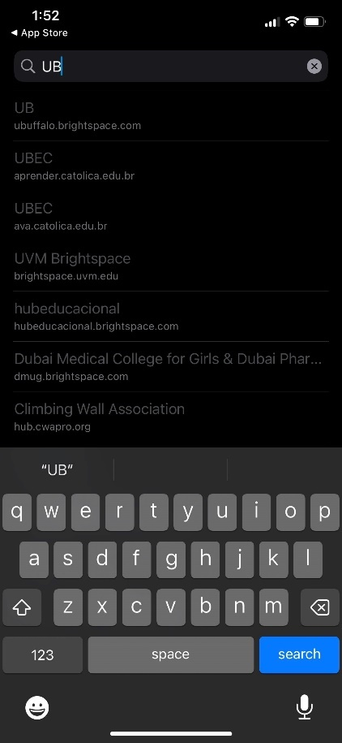
  - Select While using the app
to assist in finding the course:
  - Search for UB:
  - Welcome to UB Learns:
Scroll down to Select
Log into Brightspace
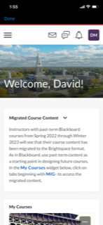
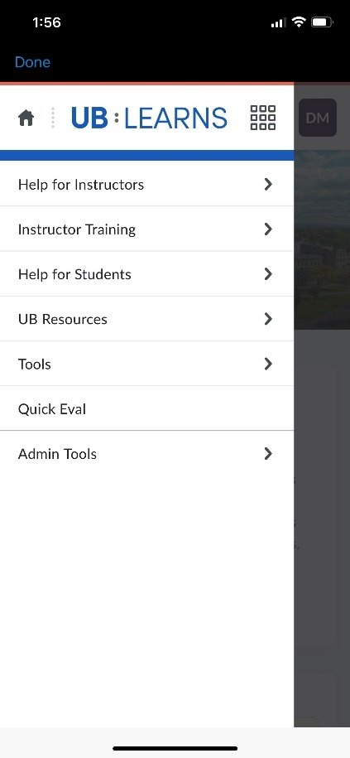
  - Enter your UBIT Name,
Your UBIT Password
Select Log In
You may be prompted for your UB Duo Two-Step Verification
  - If the course does not automatically display, you
will need to Discover the course.
    - From the UB Learns home screen
select the three lines
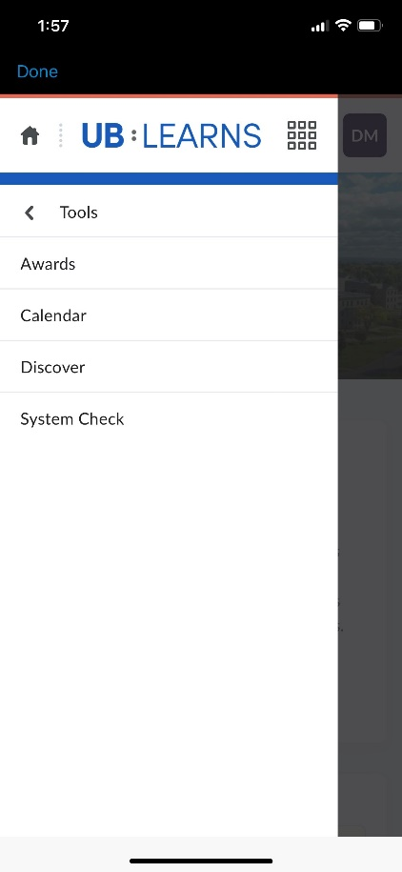
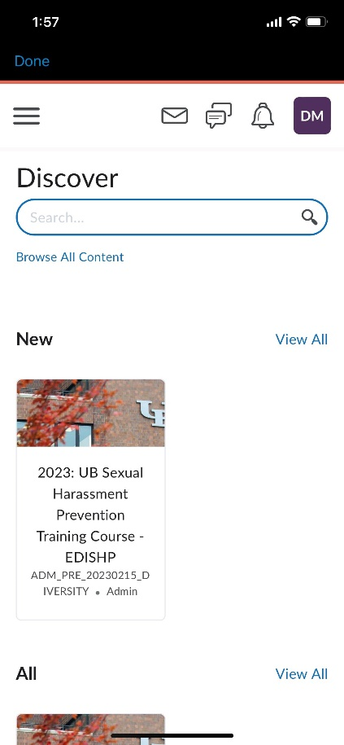
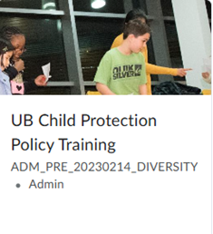
    - Select Tools:
    - Select Discover:
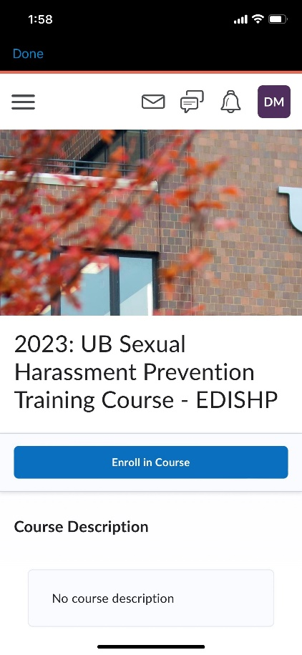
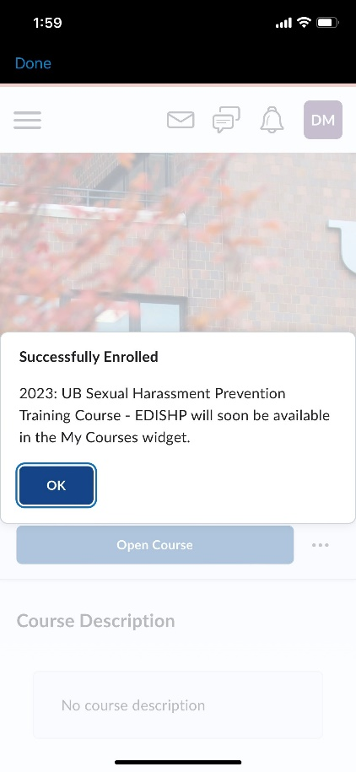
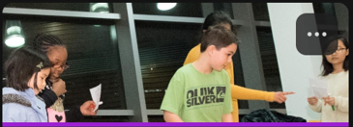
    - In Discover, the UB Child Policy
Protection Training Course
will display.
Select the UB Child Policy
Protection Training Course.
    - Select Enroll in Course
    - Select OK on the Successfully
Enrolled window
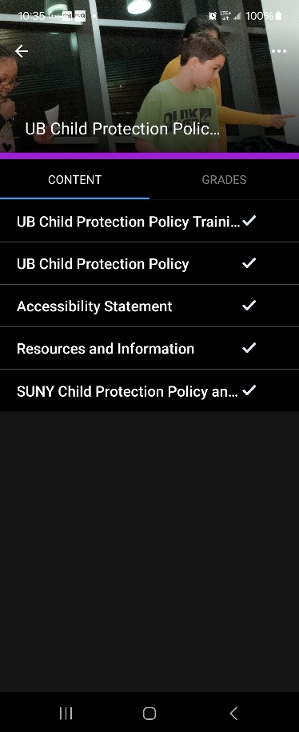
  - Begin the course:
    - Select the UB Child Protection Policy
Training Course:
      - Watch the video
      - Complete the quiz
    - Select the UB Child Protection Policy.
  - You have completed the course on your Apple Device.

